The NURTURE Study
A clinical study in newborn babies with a genetic diagnosis of Spinal Muscular Atrophy (SMA)

The NURTURE study is a clinical trial initiated by Biogen to determine if treatment with nusinersen (an approved drug, also known as Spinraza®) can delay or prevent the onset of symptoms in infants with SMA. The study began in 2015 and is still ongoing, although interim results have been released throughout the trial. All of
the children were 6 weeks of age or younger when they joined the study and were most likely to develop SMA Type 1 or 2.
The purpose of this brochure is to share information on the study with the SMA community.

What is SMA?
SMA is a rare, genetic disease which can lead to muscle weakness, problems with movement, and reduced life expectancy for people most severely affected. For people with the most severe form of SMA (Type 1), symptoms typically begin to show in the first 6 months of life. The most common symptoms include limited arm and leg movement, swallowing and feeding difficulties, and breathing problems. Infants can be diagnosed with SMA before their symptoms begin, either via a test carried out by a healthcare professional during pregnancy (called ‘prenatal genetic testing’), or once the baby is born.
SMA is caused by a change in a gene called ‘survival motor neuron 1 gene’ (SMN1). A gene is a set of instructions for making a specific protein in the body. The SMN1 gene produces a protein called ‘survival motor neuron’ (SMN) protein that is important for nerve and muscle function.
Individuals living with SMA do not produce enough SMN protein. There is a ‘back-up’ gene called SMN2 that produces a small amount of SMN protein. Nusinersen – a medicine approved in Europe in 2017 – works by increasing the amount of functional SMN protein coming from the SMN2 gene. By increasing SMN protein, nerves and muscles are helped to function properly.

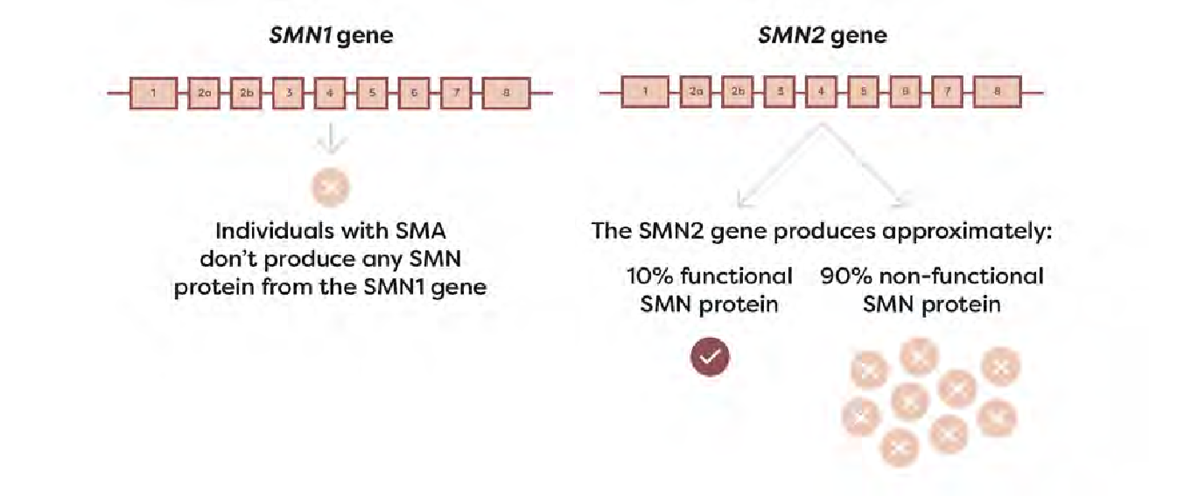
EXAMPLE SMN PRODUCTION FROM SMN1 AND SMN2 GENES IN AN INDIVIDUAL WITH SMA

Other treatments are available which can help people living with SMA, but the NURTURE study only looked at treatment with nusinersen.

Study design
When the NURTURE study was initiated in 2015, there was no approved treatment for SMA. The study was therefore carried out to find out if treatment with nusinersen is safe and could benefit people living with SMA by improving their health and wellbeing. The
study specifically looked at the treatment of 25 infants who had been diagnosed with SMA before their symptoms had begun. This is known as ‘pre-symptomatic’ SMA.
The infants who joined the study met the following criteria:
- had received a genetic diagnosis of SMA
- were 6 weeks of age or younger and did not yet have symptoms of the disease (pre-symptomatic)
- had 2 or 3 copies of the SMN2 gene (most likely to develop SMA Type 1 or 2)
The children in the study received 4 initial doses of the medicine (known as loading doses). The first 3 doses were given 2 weeks apart, and the fourth dose given 5 weeks later. For the remaining duration of the study treatment is given every 4 months (these are called maintenance doses). Throughout the study the children are regularly assessed by the study team to monitor their health and development.

Screening

≤21-day screening
4 loading doses
(at days 1, 15, 29 & 64)
Maintenance dose every 4 months
Day 1820
last visit
nusinersen 12-mg dose

The study was originally planned to treat patients until they reached 5 years of age, but in 2020 the study was extended by an additional 3 years. This will allow researchers to evaluate the longer-term effects
of the medicine on the health and development of the children up to 8 years of age, to monitor any side effects and to further understand the impact of early treatment.

Patient characteristics
- Of the 25 children in the study, there are 12 boys and 13 girls
- 15 of the children have 2 copies of SMN2 gene, 10 children have 3 copies of the SMN2 gene
- They were aged between 3 days and 42 days old when they received their first dose of treatment

Study timing and locations
The first patient joined the study in 2015. A total of 25 infants diagnosed with SMA joined the study from 8 countries across the world. The study is no longer recruiting new participants.

COUNTRY | NUMBER OF PARTICIPANTS PER COUNTRY
Australia | 1
Germany | 1
Italy | 3
Turkey | 1
Qatar | 1
USA | 15
Canada | 1
Taiwan | 2
Total: 8 countries | Total: 25 participants

What is being measured in the study?
The study is looking at the impact of treatment with nusinersen in children diagnosed with SMA before showing symptoms. The study team assess and measure the children’s physical movements, called ‘motor skills’. These include the ability to sit, crawl and walk (aided and unaided).
There are several different measures used to evaluate the children’s motor skills, including the Hammersmith Functional Motor Scale - Expanded (HFMSE).

An example of one of the measures being used in the study:
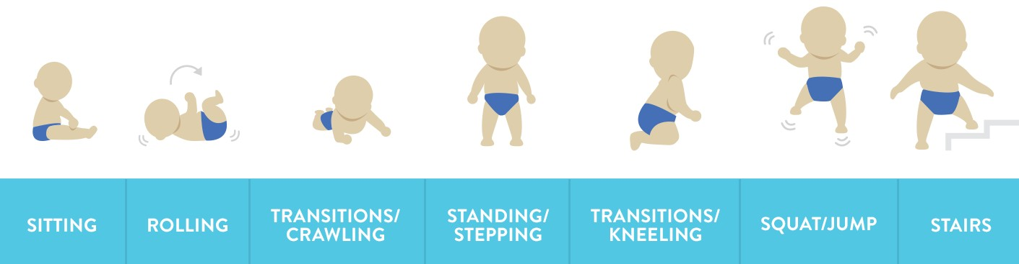
THE HAMMERSMITH FUNCTIONAL MOTOR SCALE:

The motor skill development of the infants in the study is evaluated and compared against the expected natural progression of the disease amongst infants who did not receive treatment. The safety of the medicine and any associated side effects are also being assessed by closely monitoring the health and wellbeing of the children in the study.

What has the study found so far?
As of June 2020, the following interim results were seen amongst the 25 infants who participated in the study.1 They had received up to
4.8 years of continuous treatment:
- 100 percent of children treated pre-symptomatically were alive, and none required permanent breathing support through a tube
- 100 percent were able to sit without support
- 96 percent were able to walk with assistance
- 88 percent were able to walk independently
- 92 percent were able to swallow and did not require full-time tube feeding2
These assessments were made at age-appropriate time windows – e.g. their ability to walk alone was assessed once they were ≥15 months of age.

When looking at the safety of the medicine and any associated side effects the researchers found that most side effects experienced by the participants were mild to moderate, with no serious side effects related to the study drug. No patients withdrew from the study due to side effects.1

SIDE EFFECT | NUMBER AND PERCENTAGE OF PARTICIPANTS AFFECTED
Any side effects | 25 (100%)
Serious side effects  Side effects related to the study drug† | 12 (48%)  0
Side effects possibly related to the study drug† | 11 (44%)
Serious side effects related to the study drug | 0
Side effects leading to withdrawal from study or from treatment | 0

†Assessed by the investigator

Important Note:
The results presented in this brochure reflect the results of only a single clinical trial. The information in this brochure is accurate at the time of its publication, but may not reflect other research which has been published since. It may also not reflect the approved prescribing information or availability of treatment in your country.

When will more results be available?
The study is expected to end in 2025. Results will continue to be published over the course of the study, and also once it is complete. These results will be published in the scientific literature, shared at medical conferences and can be made available only upon specific request.

Further information
Contact details for the sponsor of this trial:
Biogen International GmbH Neuhofstrasse 30, 6340 Baar, Switzerland ClinicalTrials@biogen.com
Clinical trial identifier numbers:
ClinicalTrials.gov Identifier: NCT02386553 Protocol code: 232SM201
EudraCT Number: 2014-002098-12
Further information on the study can be found at clinicaltrials.gov

Glossary
Type 1 SMA: The most severe type of SMA, where symptoms begin before the age of 6 months. Also known as infantile-onset SMA. Without treatment, these babies are typically unable to sit or roll independently.
Type 2 SMA: Children typically show symptoms between 7-18 months old. Without treatment, these children are typically able to sit, but not able to walk independently.

- Swoboda KJ, et al. Nusinersen effect in infants who initiate treatment in a presymptomatic stage of SMA: NURTURE results. Presented at Virtual Cure SMA Research Meeting 2020; June 11–12.
- Swoboda KJ, Sansone VA, De Vivo DC, et al. Preserved swallowing function in infants who initiated nusinersen treatment in the presymptomatic stage of SMA: results from the NURTURE study. Presented at MDA Clinical and Scientific Conference 2021; March 15–18.

www.biogen.com
Biogen-111687. September 2021.

